Session 2025-2026(EVEN)

Vision: Dream of where you want. | Mission: Means to achieve Vision

Program Educational Objectives of the program (PEO): (broad statements that describe the professional and career accomplishments)
PEO1 | Preparation | P: Preparation | Pep-CL abbreviation  pronounce as Pep-si-lL easy to recall
PEO2 | Core Competence | E: Environment (Learning Environment)
PEO3 | Breadth | P: Professionalism
PEO4 | Professionalism | C: Core Competence
PEO5 | Learning Environment | L: Breadth (Learning in diverse areas)

Program Outcomes (PO): (statements that describe what a student should be able to do and know by the end of a program)
Keywords of POs:
Engineering knowledge, Problem analysis, Design/development of solutions, Conduct Investigations of Complex Problems, Engineering Tool Usage, The Engineer and The World, Ethics, Individual and Collaborative Team work, Communication, Project Management and Finance, Life-Long Learning

PSO Keywords: Cutting edge technologies, Research

“I am an engineer, and I know how to apply engineering knowledge to investigate, analyse and design solutions to complex problems using tools for entire world following all ethics in a collaborative way with proper management skills throughout my life.” to contribute to the development of cutting-edge technologies and Research.

Integrity: I will adhere to the Laboratory Code of Conduct and ethics in its entirety.

Name and Signature of Student and Date
(Signature and Date in Handwritten)

Session | 2024-25 (EVEN) |  | Course Name | Java Full Stack Development Lab
Semester | 4 |  | Course Code | 23ADS1407
Roll No | 129 |  | Name of Student | Vidhi Chavhan
Practical Number |  | Practical 3
Course Outcome
Aim |  | WAP to design a simple calculator using control  statement
Problem Definition |  | The aim of this program is to design a simple calculator using control statements.  It performs basic arithmetic operations such as addition, subtraction, multiplication, and division.  The program takes two numbers and an operator as input from the user.  Control statements are used to select and execute the required operation.
Theory  (100 words) |  | - simple calculator program is used to understand the concept of control statements.  - Control statements like if–else or switch–case are used for decision making.  - The program accepts two numbers as input from the user.  - It also takes the user’s choice of arithmetic operation.  - Basic operations include addition, subtraction, multiplication, and division.  - Based on the selected option, the corresponding operation is executed.  - The result is then displayed to the user.  - The program helps improve logical thinking and problem-solving skills.  - It introduces structured programming concepts.
Procedure and Execution  (100 Words) |  | The program begins by displaying a menu of arithmetic operations to the user. The user is prompted to enter two numerical values and select an operation such as addition, subtraction, multiplication, or division. Using control statements like if–else or switch–case, the program checks the selected option and performs the corresponding calculation. During execution, the program processes the input values according to the chosen operation and computes the result. If division is selected, the program verifies that the divisor is not zero to avoid errors. Finally, the calculated result is displayed on the screen, and the program terminates successfully
Code:
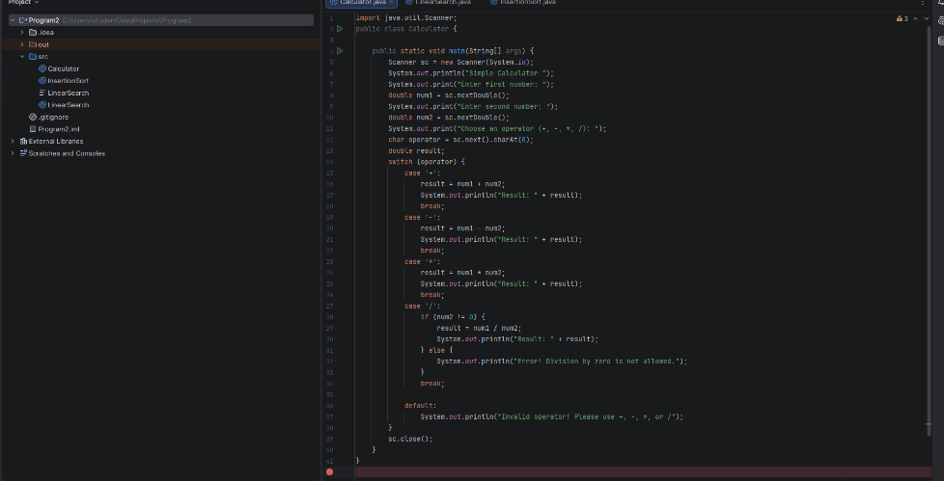
Output:
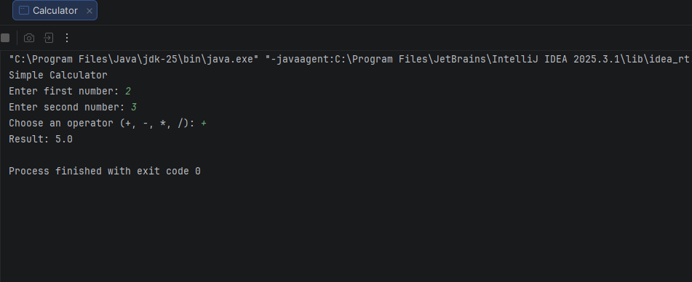
Output Analysis |  | - The program displays a menu showing available arithmetic operations.  - The user enters two numbers and selects the desired operation.  - Based on the selected option, the program correctly performs the calculation.  - The output shows the result of addition, subtraction, multiplication, or division.  - If an invalid option is entered, an error message is displayed.  - In case of division by zero, the program warns the user and prevents execution.  - The output confirms that control statements work correctly to manage program flow.
Link of student Github profile where lab assignment has been uploaded |  | https://github.com/vidhichavhan18-cell/Java-Installation
Conclusion |  | This program successfully demonstrates the use of control statements to design a simple calculator.  It performs basic arithmetic operations accurately based on user input.  The program helps in understanding decision-making and logical flow in programming.
Plag Report (Similarity index < 12%) |  | 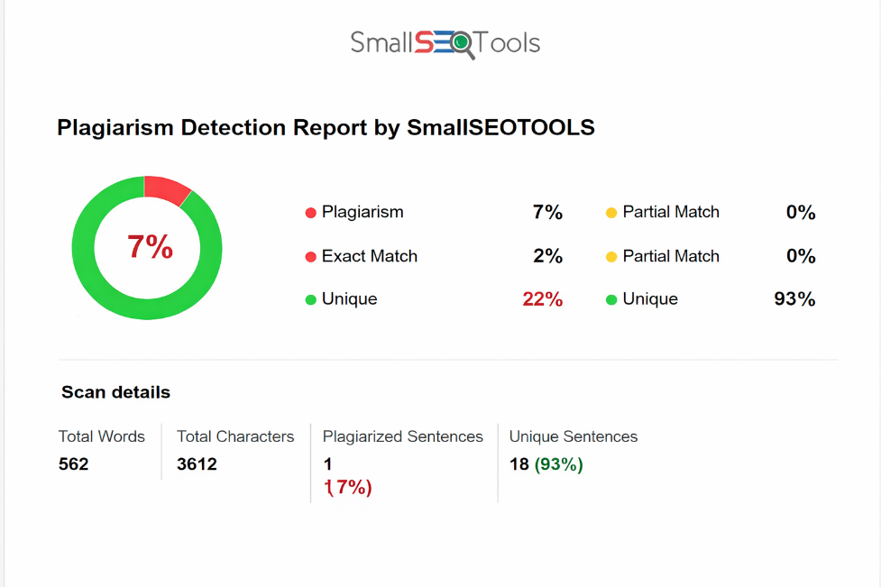
Date |  | 28.02.2026

Observation copy screenshot

